Matt Tranchina 07/14/2024

CS Comp Graphic and Visualization Project Proposal

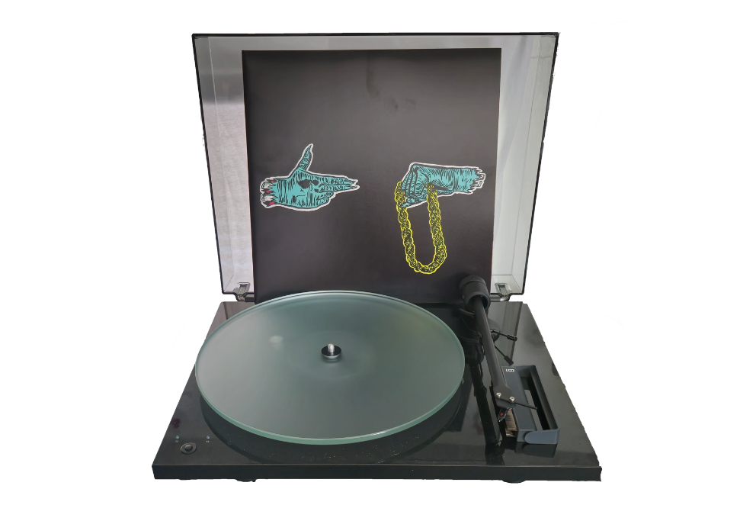

The image I have selected for the final project is my record player. The album above the record player is the first album of the group Run The Jewels. Considering this concept is rather difficult for me as of right now, I will be replicating the record player itself. Depending on how difficult the objects on the album are, they may be discarded. The record brush, located bottom right under the tonearm, will not be replicated.

I chose this image because it has many basic shapes. The player itself is a thin box, or a plane, with a flat cylinder-shaped record placed on top. The tonearm is made of various cylinder shapes with two torus shaped weights at the end. The tonearm handle could be made by a thin cone with two small torus “bolts” placed on top. The button on the bottom left will be made with a small sphere surrounded by a torus.

The album cover is going to be a little trickier. The left hand could be made, starting at the left and working towards the right, with two cylinders going into a box overlapping a sphere with 5 various elongated cylinders. The three fingernails could be made with cones. The right hand could be made with, starting from the right working towards the left, two cylinders going into a box with four cylinders pointing down and having 4 cylinders overlapping at a 90-degree angle. The “thumb” could be a cylinder with a cone on the edge. The chain could be made with multiple torus shapes, giving the illusion of a rope. While I may be biting off more than I can chew, I will attempt to render this image, but it may be removed.